Connect to EC2 Instance using SSH

Today, AWS is introducing [Amazon EC2 Instance Connect](https://aws.amazon.com/about-aws/whats-new/2019/06/introducing-amazon-ec2-instance-connect/), a new way to control SSH access to your EC2 instances using [AWS Identity and Access Management (IAM)](https://aws.amazon.com/iam/). Here are the step by step process for connect your ec2 instance with ssh .

Aws Ec2 Instance steps:

1. Open Aws management console, go to services, Under the Compute services click Ec2 Instance.
2. Click Launch Instance, after that you will be prompt on Choose an Amazon Machine Image (AMI).
3. Choose your Instance type or we can say O/s According to your preferences. i.e Amazon Linux, Window, Linux, Ubuntu.

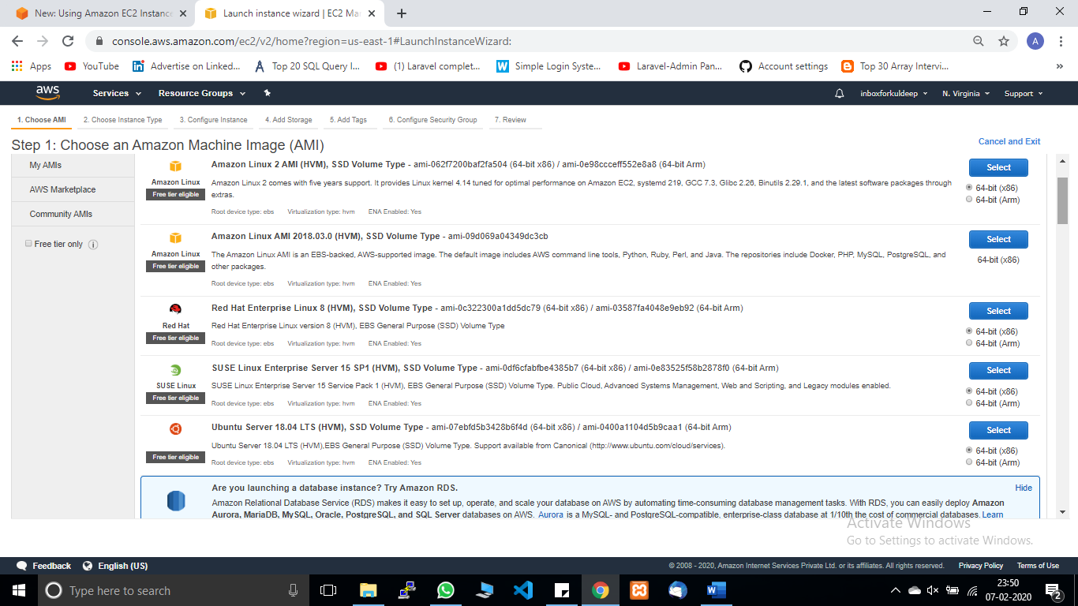

1. After Selecting Instance o/s, next step is to Choose an Instance Type like nano, micro, macro, small, large (please kept in your mind aws will charge you as per your preference so select type as your need micro tier is free).

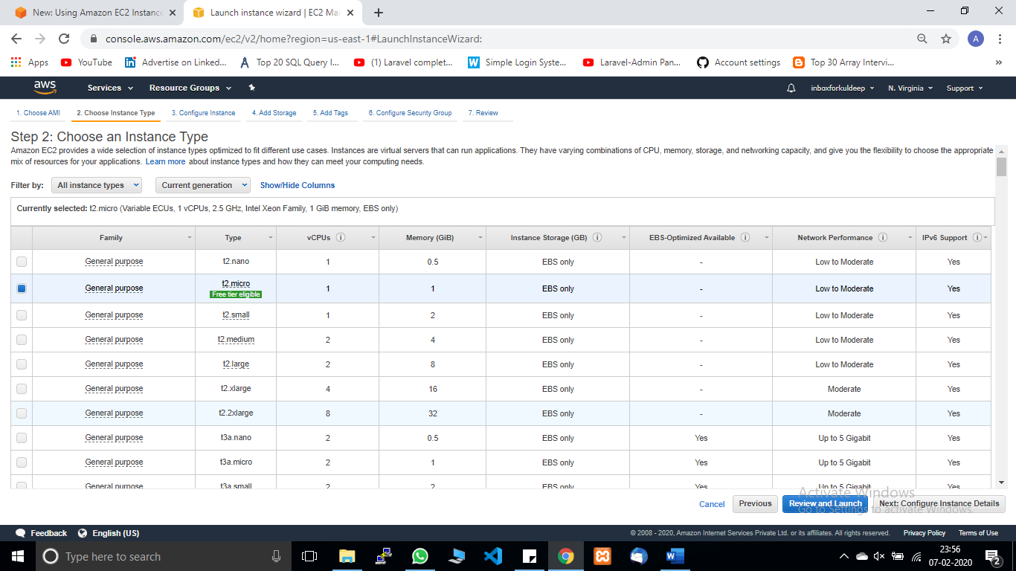

1. Click next configure instance details.
2. Click next add storage. Add storage as per your need.

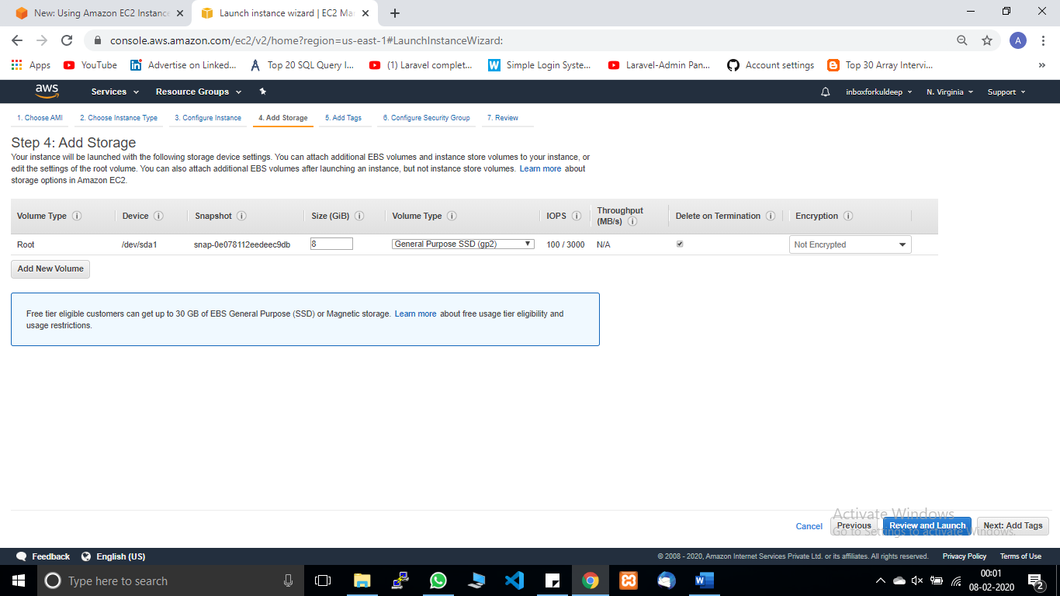

1. Click next add tag. tag is use for identified with unique identity.
2. Click next configure security group. In security group you can choose your existing group and also create a new one.

Add Rule: SSH mandatory, for connection other you define that you want to allow the traffic on your instance.

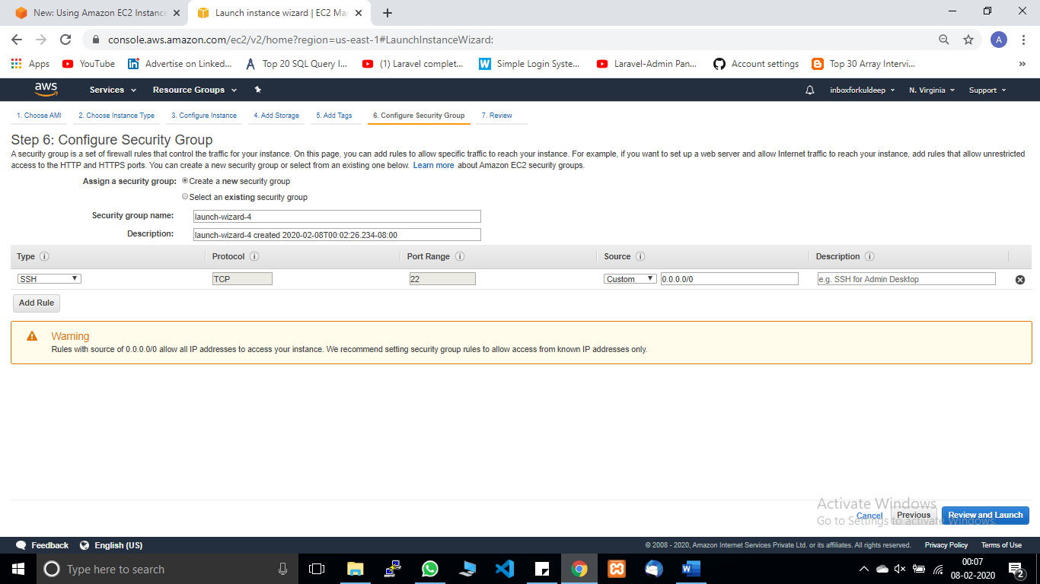

1. Click review and Launch. Click Launch. while you click on launch button a pop is prompt on screen for Generate keypair, generate key pair and download and save on secure location (Do not delete this file). Launch Instance.

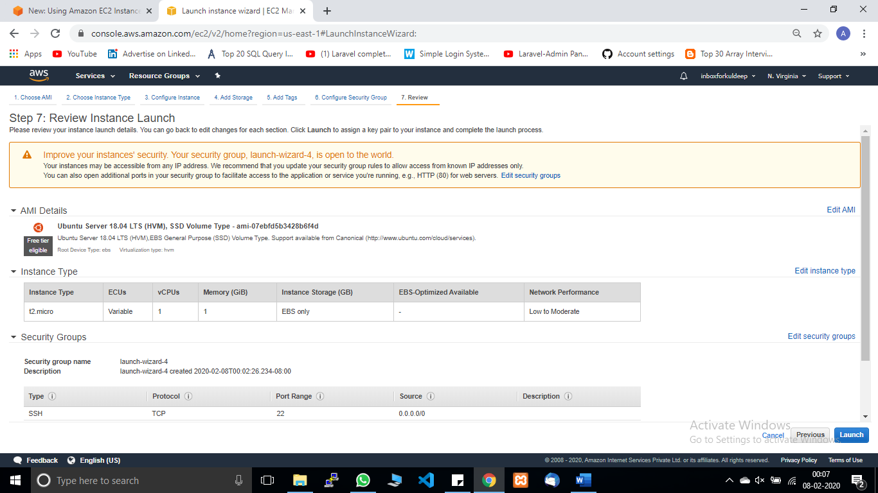

1. View Instance it might take some time and then you will ready to go with instance. you can cross verify by checking your instance state is running or not.

SSH Connection with Instance:

In this section we can connect our instance with SSh client, for that reason I need to download and install Putty and Putty gen software .Putty client is opensource and freely available on internet that are use for remote connection .

1. Generate Private Key .
2. So Now we need our downloaded key pair that are in pem extension.
3. Open putty gen and Load your private key pair after loading successfully .

1. Click generate private file and save your save this time your file is in ppk format

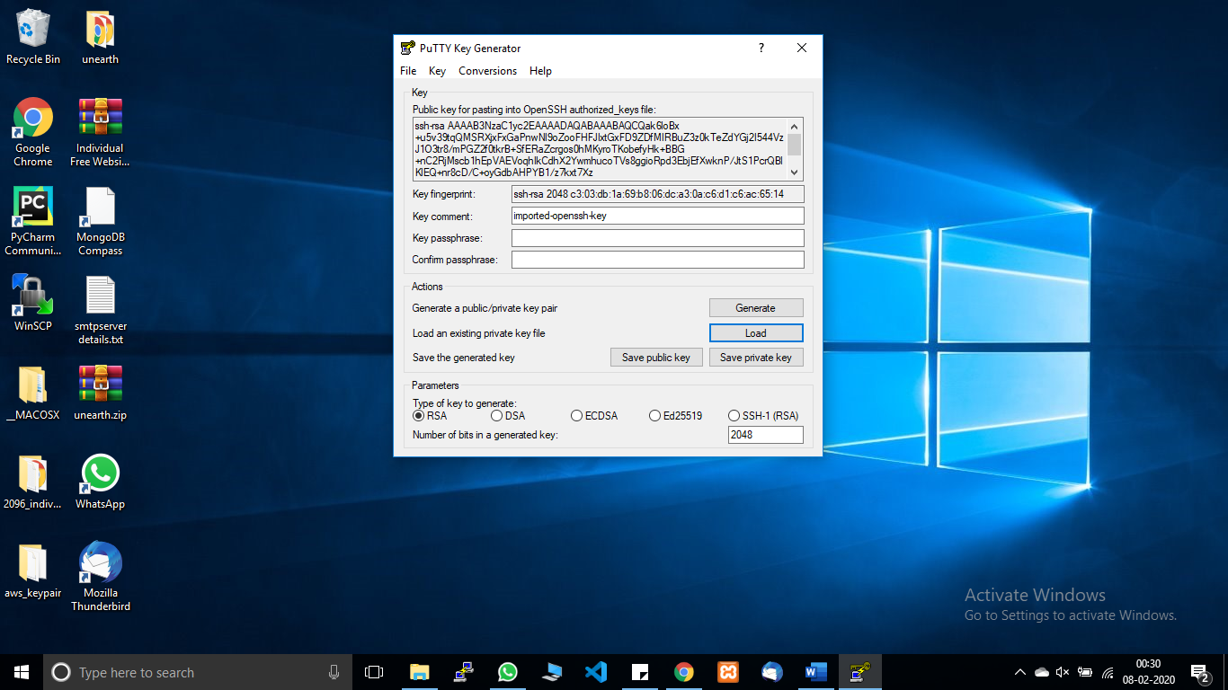

1. Open putty and enter your DNS OR IPV4 of your instance.
2. Go to the connection tab, Under SSH directory click Auth and browse your ppk file, in the right-hand side click open.

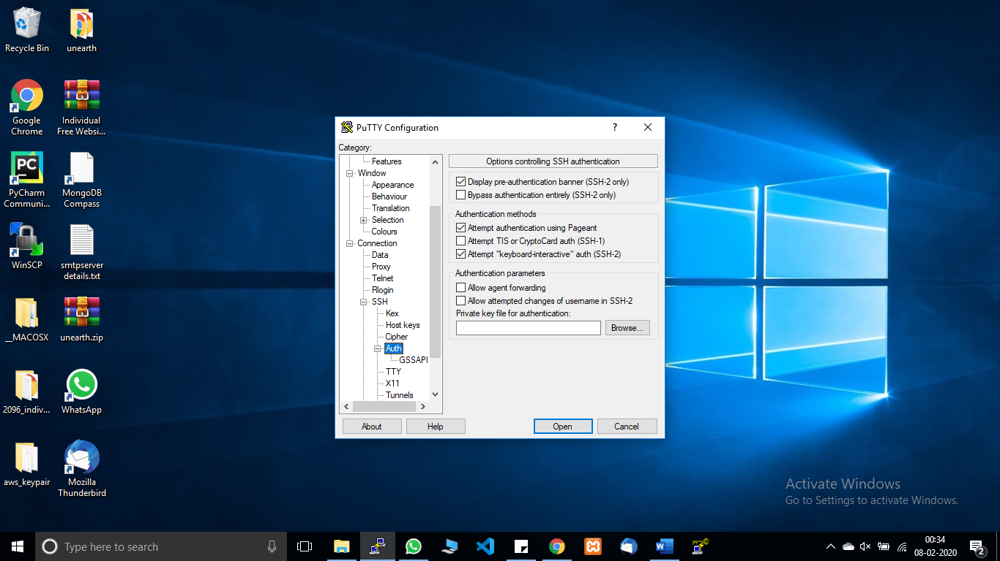

1. putty will open your instance on remote connection and ask for security alert, click yes, and you will be on your remote instance.

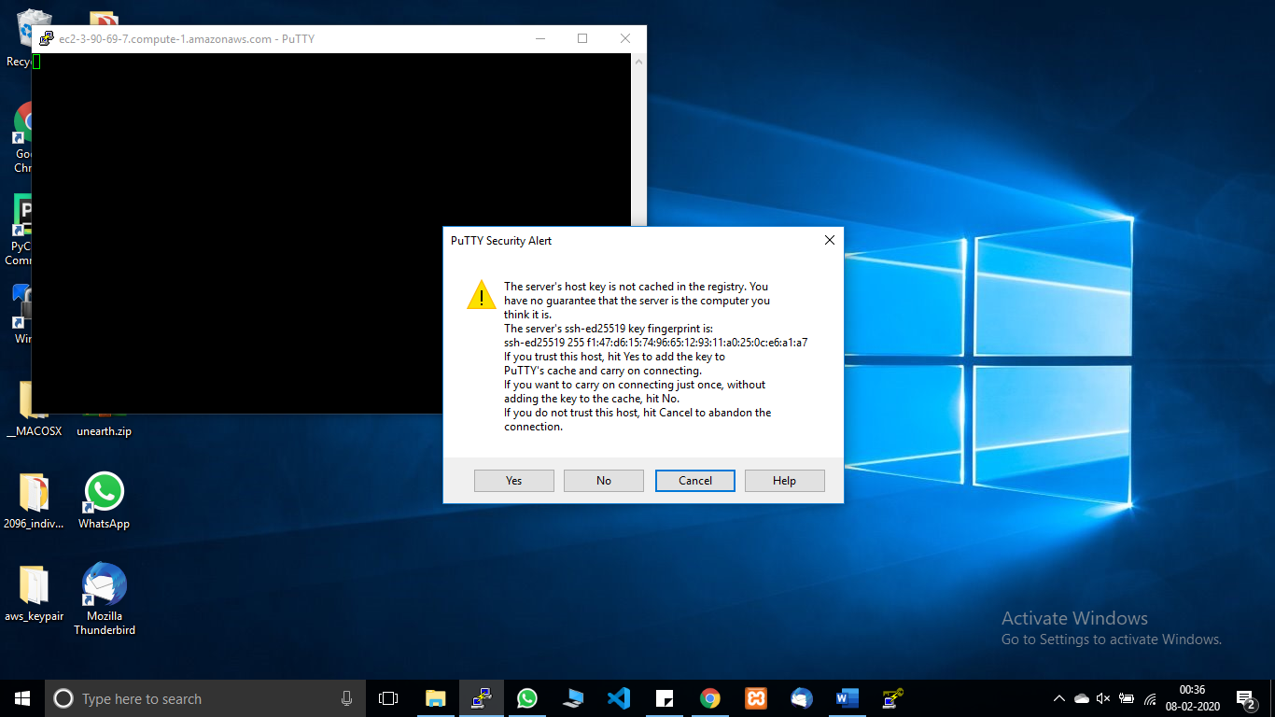

1. Login with your root name As I Created ubuntu instance my root name is ubuntu, for window is Administrator, and for Linux is ec2-user.

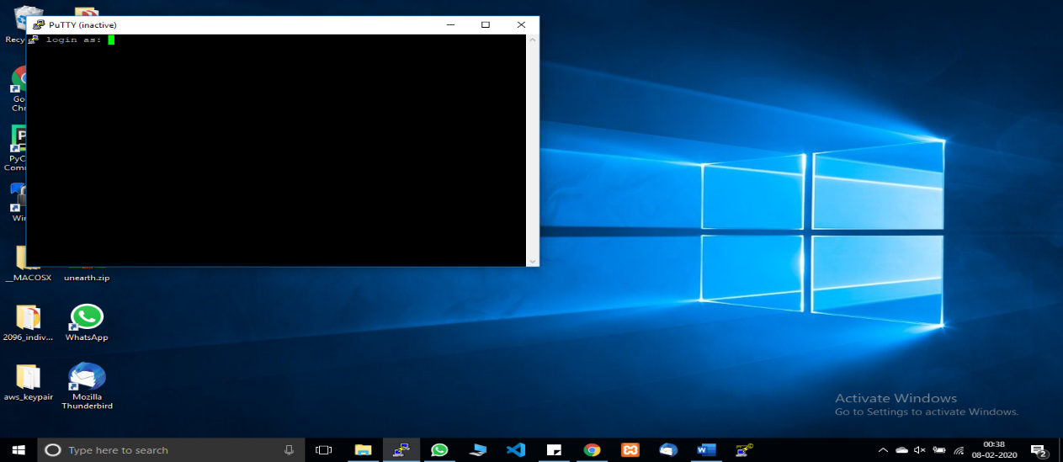

1. Right Now, you are in your ec2 Instance.

